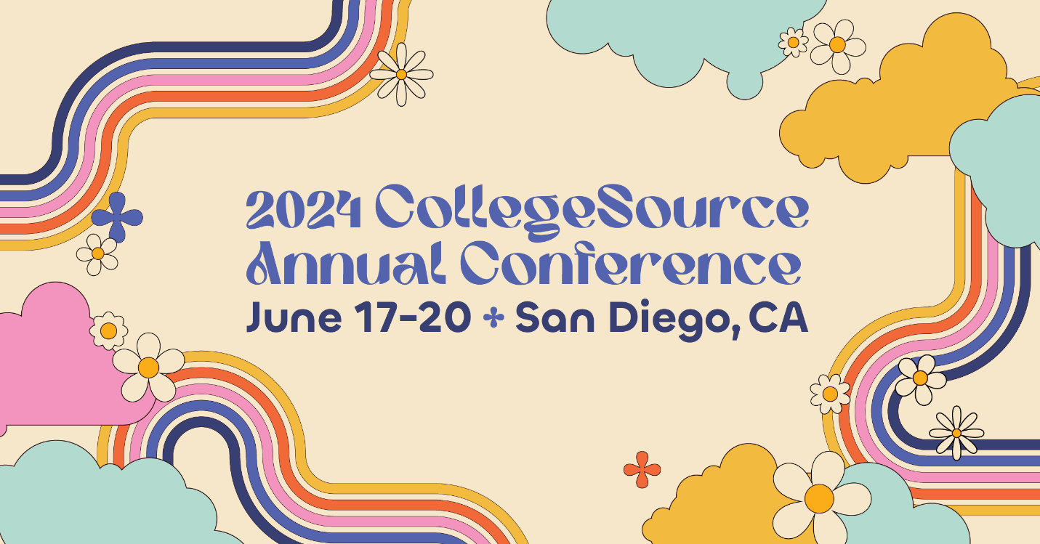

Your Guide to Making the Case

- Choose the sessions you’re most excited about from the conference agenda (links on page 3) and align them with your current goals and objectives at your institution.

- Read the common objections on the next page and be ready to answer them confidently. Don’t hesitate to use the additional justification resources we put together on page 3 to help further make your case and explain why attending the conference will benefit you and your institution.

- Once you’ve got everything together, customize the Justification Letter we’ve put together for you on page 4 (in-person conference) or 5 (virtual conference).

Did we miss anything to help you make your case?
Or, do you need more help? Email us at marketing@collegesource.com.
Learn more at collegesource.com/2024

Responses for Common Objections

Objection #1: “The conference is too expensive.” Or “There’s no room in the budget.”
Response: What are the costs of not attending? Be prepared to provide examples of how product and feature-specific training offered at the conference will positively affect your position, day-to-day tasks, and the processes in place at your institution. Specific examples, such as certification opportunities, could also be worth mentioning.
Also, make sure to talk about the networking opportunities available at the conference and the value of connecting with CollegeSource staff as well as those in similar positions at other institutions in your state and across the country. And if you want to bring your team, talk about the benefits of learning together or being able to divide and conquer while attending.
Objection #2: “Why attend the CollegeSource Annual Conference when there are much larger regional or national shows you can attend?”
Response: Because the CollegeSource Annual Conference is smaller and focused solely on [TES / Transferology / uAchieve], I won’t be wasting my time with sessions that do not address our/my particular challenges or be distracted by third-party vendors. The entire agenda for the conference is developed to revolve around training and networking.
Also, the ratio of CollegeSource staff works out to be about one staff member for every five attendees. And in addition to being product experts, they have over 240 combined years of service in higher education. This means CollegeSource staff will not only understand my challenges, but I’ll also have the chance to work with them one-on-one to implement new tactics and strategies when I return.
Objection #3: “It’s too much time away from work.”
Response: The in-person conference is scheduled for the end of June to avoid any busy registration or graduation times with the fall and spring semesters. By attending a conference that is purposely scheduled to avoid conflict with the busier times of the year, I’ll be able to entirely focus on training throughout the three to four days of the conference. I’ve also come prepared with a plan for covering my responsibilities while I’m attending the conference.
Objection #4: “You can learn the same content from free webinars and Support Center articles.”
Response: While those learning opportunities can fill some gaps, they can’t replace the annual conference experience. At the CollegeSource Annual Conference, I’ll meet others in similar positions facing the same challenges we are. In addition, this conference provides the opportunity to connect and network directly with CollegeSource staff and others from higher education institutions across the country to ask specific questions I have so we can meet our goals.

Need a little more justification?

Below are some additional resources you can grab and share with the decision-makers at your institution:
- Share this video we put together to recap a past annual conference and show how the attendees learned new skills, shared their successes, and created new connections along the way!

- Need specific examples of sessions or to show what the schedule is? Check out the agenda and the Schedule page on our conference website to see the upcoming conference schedule and sessions. Or, drop in specific examples from the 2024 agenda:

  - CollegeSource-led sessions:
    - Getting on Board with the Evaluation Tracker Workflow (TES)
    - It Came From Outside a College: Non-Traditional Sources of Credit in TES
    - Transferology Beach Bash: Unleash the Party with Promotion and Usage Best Practices
    - Transferology’s Technical Landscape
    - Upgrading to uAchieve 5.1 On-Premises (Pt. I): Install and Configure Self-Service
    - Upgrading to uAchieve 5.1 On-Premises (Pt. II): Install and Configure the Server and Build Course Catalog Indexes
    - Encoding for Planner: New Fields in 5.0 and 5.1
  - User presentations:
    - TES Maintenance (California Baptist University)
    - Transferology – How to Stick the Landing (University of Illinois System/Illinois MyCreditsTransfer)
    - Surf’s Up: Ride the Wave of Course Bundles in Transferology (Multiple Institutions)
    - University of Minnesota’s Program Matcher Success Story (uAchieve focus)
    - USC’s Migration Experience from DARWIN to uAchieve Cloud – A Success Story

- Pass along some testimonials…
“I have attended many conferences in my higher education career and this was, by far, the best one. The sessions were engaging, the activities were fun, the staff/ambassadors were available for anything we needed, the venue/location was beautiful, and all of the events were spectacular. Thank you so much for putting on one of the most engaging conferences in my career.”
“The sessions were engaging, the activities were fun, and staff were available for anything we needed.”
“This is a wonderful conference for learning, networking, and having some fun along the way. Sessions provide information on what’s new, how to’s, and the ability to connect with others to find out what campuses are doing around the country. CollegeSource staff are readily available to answer questions and provide help. I love the ‘family’ feel of this conference. Looking forward to next year’s conference already!”

<The rest of this page was intentionally left blank>

Dear {insert},
I would like to attend the CollegeSource Annual Conference that will be held June 17-20, 2024, at the Bahia Resort Hotel in San Diego, California, to further the value of our {insert product name} solution by CollegeSource.
The following is a list of my top three priorities to accomplish at the CollegeSource Conference:
- {insert}
- {insert}
- {insert}
The impact of my attendance will be seen immediately. This conference is comprised of 60+ breakout sessions to choose from during the course of three days. These sessions will provide technical and functional in-depth training on degree audit, academic planning, and transfer solutions. In addition, this is a unique training opportunity where I will have access to one-on-one time with CollegeSource staff and the ability to network and share ideas with my peers who face similar challenges.
The registration cost includes a discounted hotel rate, receptions Sunday and Tuesday nights, and breakfast, lunch, and refreshment breaks Monday - Wednesday.
Below is the approximate cost to attend:
Airfare: | {$insert}
Transportation: | {$insert}
Hotel (# nights at $270 + 12.55% state and local taxes/fees): | {$insert}
Meals (breakfast, breaks, and lunches Tue-Thu, and appetizers on Monday night and dinner on Wednesday night are included in the registration fee): | {$insert}
Registration Fee: | {$insert}
Approximate total: | {$insert}

Upon my return, I will share knowledge with key team members in my department and other relevant personnel. In addition, I would be happy to submit a report with my takeaways, tips and tricks, and recommendations on maximizing our use of {insert product name}.
Thank you for considering this request. I look forward to your reply.
Regards,
{insert},

